Users step-by-step registration
Below is the user registration process. In order to get started you need to:

1. Go to: https://scalesandtales.magicbooking.co.uk/Identity/Account/Login
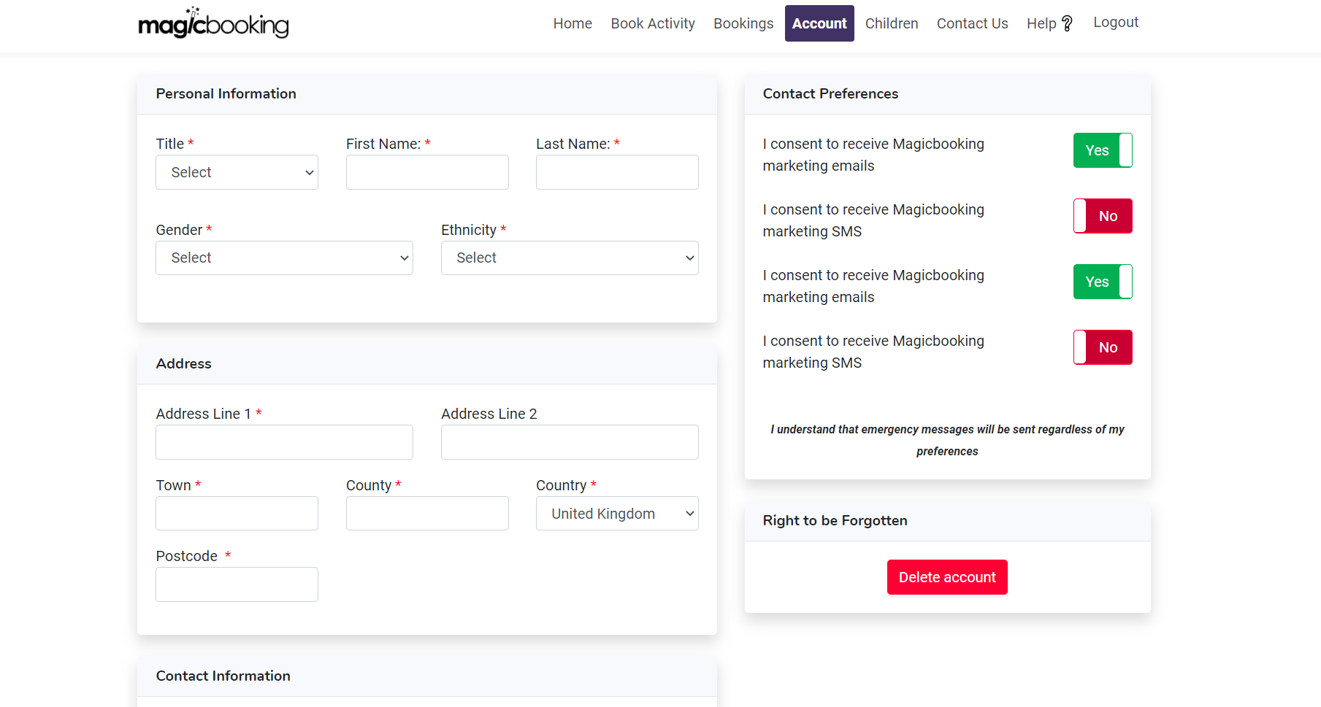
Note: Step-by-step instructions and videos are also available from the parent’s portal under the Help section!

2. From the login page, select Don't have an account yet? Create one here:

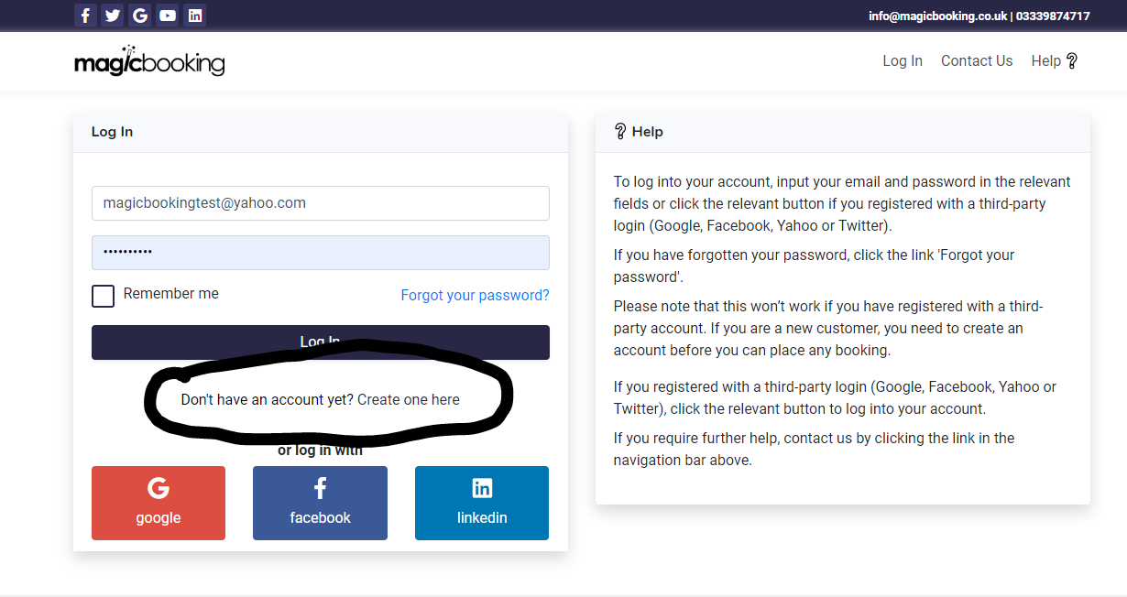

3. CREATE YOUR ACCOUNT

You will need to create your account with a valid email address. You will need to validate it via the link sent to your email. (One account per family should be created).
Fill in the registration form and follow the process on the screen.
Once you have completed the registration process, an email will automatically be sent to you. Open the email and validate your account by clicking the link provided.

If your centre has already pre-loaded your account or if your account was imported from the schools’ management system, when you reach the login page, simply click the ‘Forgot your password?’ link and follow the instructions received in the email sent to setup your password and log in to your account.
If your account was imported from a school management information system, your data and your children's data would have been created in magicbooking. In this case, you only need to review the consent questions (Step 5 - Consents).

4. REVIEW YOUR PERSONAL INFORMATION

Go to “Account” -> Account Details and complete any missing data that is required (address, contact details and mailing preferences etc.).

5. ADD CHILDREN TO YOUR ACCOUNT

To create children, you need to navigate to the Children section, and then click “Add child”. You will be taken through a step-by-step form that needs to be completed and saved.
Note: Only 1 child can be created at a time.
Now click each tab (Medical Info, Disabilities, Emergency Contacts, Collectors and Doctors) and fill in the relevant information.
Only Emergency Contacts, Collectors and Doctor details are reusable if you have more than one child created.

Consents:
Review and answer all consent questions. All must be answered before you are able to make a booking for that child.

Medical information, Medication, Dietary Needs & Allergies:
Click “Add” in the relevant section to add Dietary Needs, Medical Conditions, Medications and Allergies. You can add more than one in each section if needed. Make sure you complete all details, including emergency treatment if relevant, as it is important for your child’s well-being and ensures that staff are aware of any health problems or medication your child might have or require.

Disability & Special Educational Needs (SEND):
Again, it is important for your child’s well-being and safety that staff are aware of any Disabilities or Special Education Needs your child might have. Hiding such information may result in your child being turned down at the door if no resources are available to provide adequate care to them.

Emergency Contacts and Collectors:
When you register, your contact details are automatically added on both the Emergency and Collectors lists, however, it is advisable to add another emergency contact in case you are not reachable in the event of an emergency. Some organisations impose more than one emergency contact, so if it is the case you won’t be able to make a booking until you have entered the requested number of contacts.
You can’t use the same phone number or email for two emergency contacts.

Doctors:
This is the contact details of the Surgery your child is registered with.
Note: When you register a second child, additional contacts (collectors, emergency contacts and doctors) can be reused. Simply tick the relevant check boxes at the bottom of the child’s details form. This allows you to avoid re-entering the same information again.

6. HOW TO BOOK A SESSION

Once you have completed the above steps, you can start to book activities.
The system automatically checks your child’s age group/classroom and only activities available to your children will be displayed.

